**TUTOR AYO**

**NOU107**

**TMA SOLUTION FOR EXAM STUDY**

**DO NOT REPRINT FOR SALE**

**THIS IS FREE AND SOLELY FOR EXAM STUDY**

Join our general Whatsapp group for regular updates

 **<https://chat.whatsapp.com/InKqirCrhnF9KJozucXWCh>**

 **<https://tutorayo.com/>**

1. One of the factor that is making open distance learning an indispensable element in Nigeria is ____

ANS. Lifelong learning

2. When teaching and learning process involves an interaction among the teacher, the students and the content is called ___

ANS. learners' centred

26. In online education teacher serves as ___

Question 3Answer

a.educator

b.technologist

c.facilitator

d.administrator

5. ____ with peers in the discussion groups can be an effective way to motivate learners to stay on task

a.conjunction

b.presentation

c.collaboration

d.practical

1. Which of the following is most correct about the educational philosophy emphasized for open learning?

a.Media of learning, place and pace of study, support mechanisms, entry and exit points

b.Medium or media of learning, place and pace of study

c.Enhancing learning opportunities within formal education system

d.Learning at your own pace and place

9. The second stage of development of distance education is referred to as __

a.Open and Distance Learning

b.Computer Technology Stage

c.Sound and Video Signal Stage

d.correspondence stage

1. How many chapter can you find in a research project?

a.4

b.5

c.6

d.7

14. The following are considered appropriate for an instructors to ensure that their methods of assessment are effective EXCEPT

a.ensure validity and reliability

b.maintain balance

c.strive for clarity

d.maintain logical conclusion

2. What to avoid during exams include poor presentation, using time badly and ____

Question 9Answer

1. using material from the course

b.seeking assistance from the peers

c.seeking information from the peers

d.not using material from the course

43. The mode of operation in National Open University of Nigeria is referred to as ___

a.Dual

b.Mono

c.Double

d.Tripple



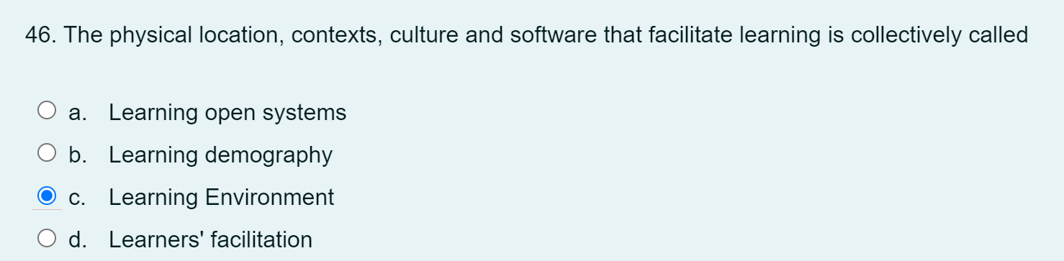

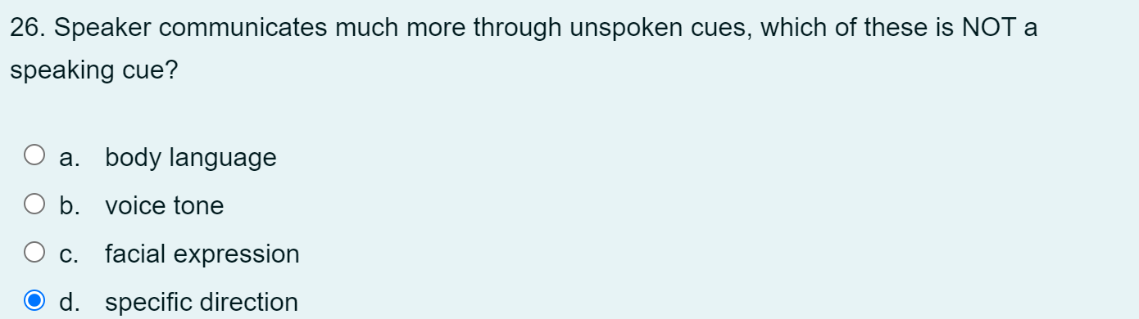

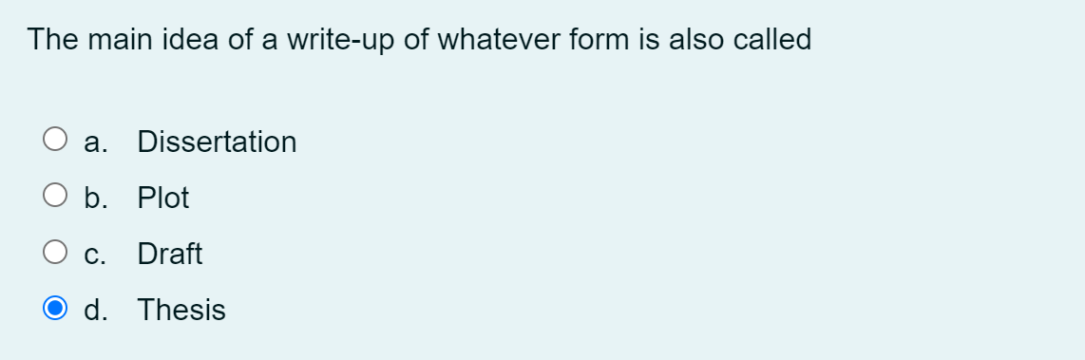

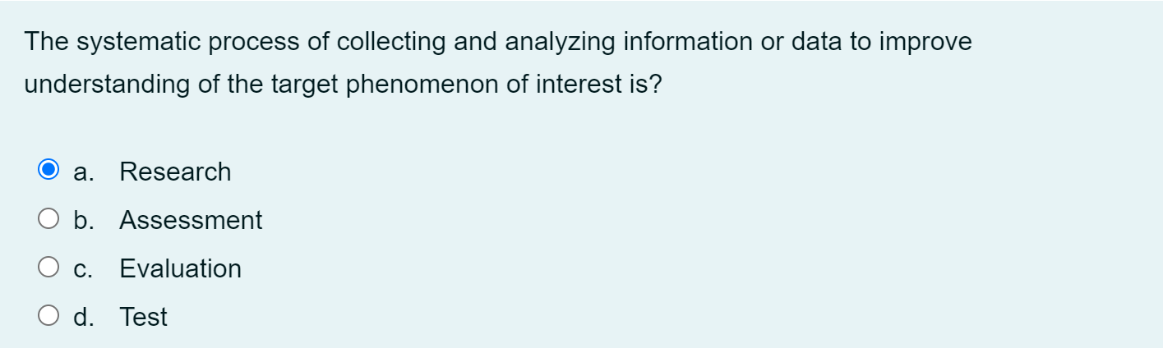

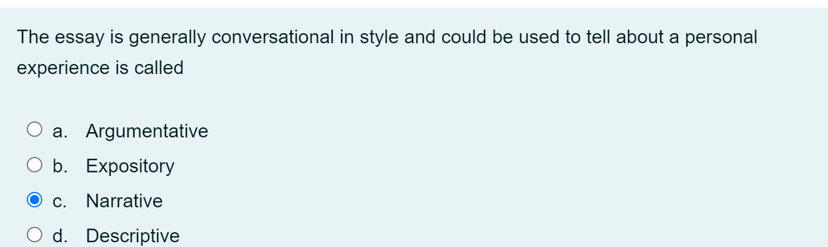

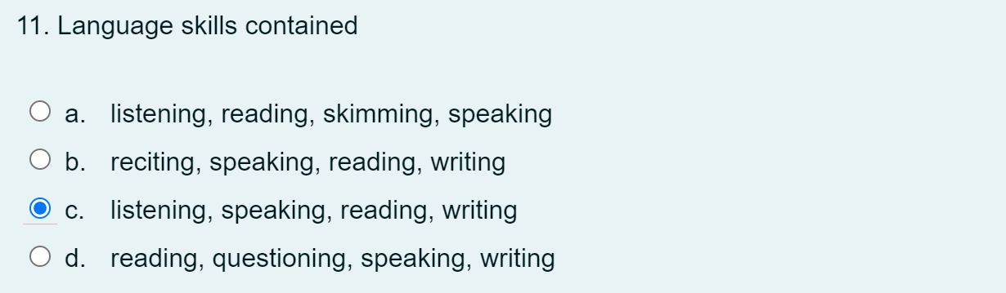

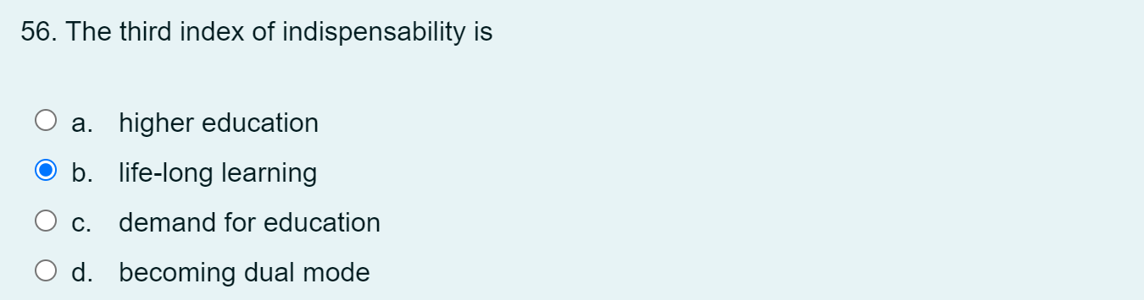

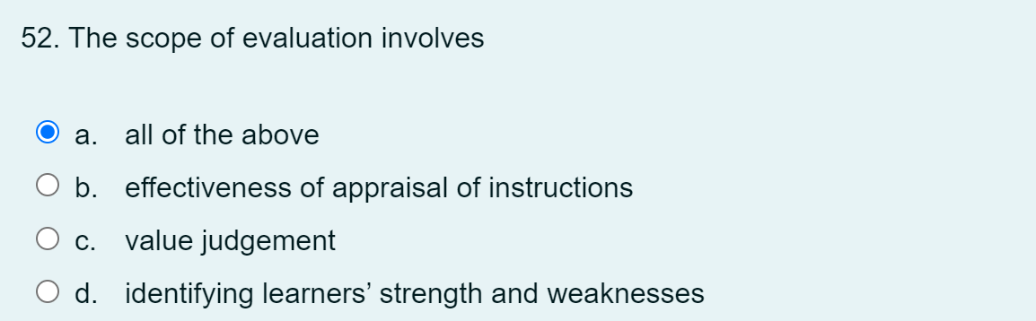

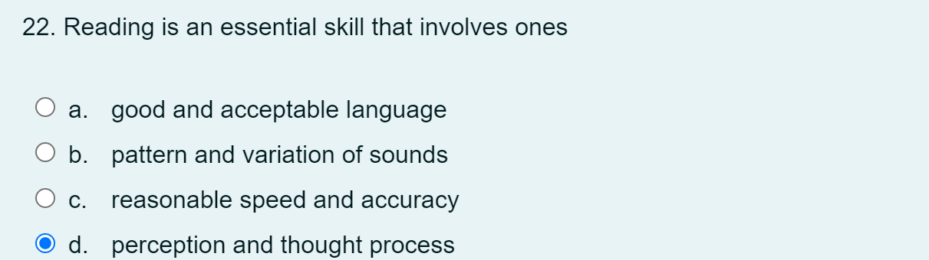

16. What is the current trend in open universities?

1. the administration of examination twice in a semester

52. Who do you write to, to request your transcript to be sent to another university where you intend to further your education?

c.The Registrar

1. Which of the following will you use to confirm what students already know and what they can do in relation to the programme of studies?
2. Assessment of Learning

34. When Yagana is asked to write to convince her reader about the validity of her opinion, what type of essay will that be?

a.Narrative

b**.Argumentative**

c.Descriptive

d.Expository

20. What is the result of peripheral participation in collaborative discussion?

c.not allowing for active mastery of concepts

1. Where is the right place for prospective student to make enquiries?

a.Ministry of Education

b.Handbook

**c.Study centres**

d.Internet

1. Which of the following do not ensure quality of assessment?

a.Neatness

1. What section in NOUN establishes the curriculum for each of the programme the students?

a.Exams and Records

b.Library

c.Registry

**d.Departments and Faculties**

1. What is the process of making a value judgement called?

a.Assessment

b.Examination

c.Testing

**d.Evaluation**

22. What mode of listening Dauda listen in a social setting?

a.listen to get information

b.listening for a specific purpose

c.listening in general

**d.listen to get information or direction**