**TUTOR AYO**

**ENT101**

**TMA SOLUTION FOR EXAM STUDY**

**DO NOT REPRINT FOR SALE**

**THIS IS FREE AND SOLELY FOR EXAM STUDY**

Join our general Whatsapp group for regular updates

 **<https://chat.whatsapp.com/InKqirCrhnF9KJozucXWCh>**

 **<https://tutorayo.com/>**

1. According to ………..., an entrepreneur is a manager scientist, or researcher who works inside an existing organization and notices opportunities for product improvements and is responsible for managing the product development process.

Ans. Jones, George and hill (2000)

1. All except one are factors to be considered in choosing a business opportunity

Ans. employees vacation

1. ……….. is a systematic way of gathering analyzing and interpreting marketing data that will aid the entrepreneur in making marketing decisions.

Ans. market research

1. ……….is the process of setting objectives and coordinating resources, including people, in order to attain those objectives

Ans. Management

1. OECD stand for

Ans. the organization for economics cooperation and development

1. The …………….. economy stands in direct contrast to the centrally planned system

Ans. free market

1. …………… plays an important role in understanding employees behavior in different cultures. It is important for any company competing internationally to understand cultural differences

Ans. national culture

1. A ………………. Is a civil wrong other than a breach of contract or a breach of trust and is a duty fixed by law on all persons

Ans. tort

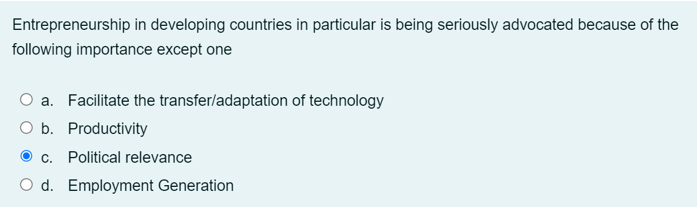

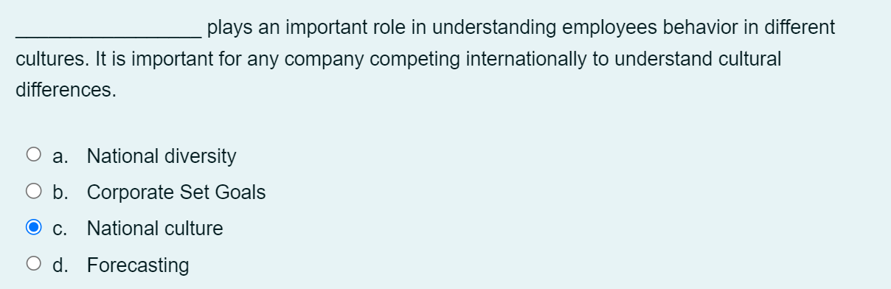

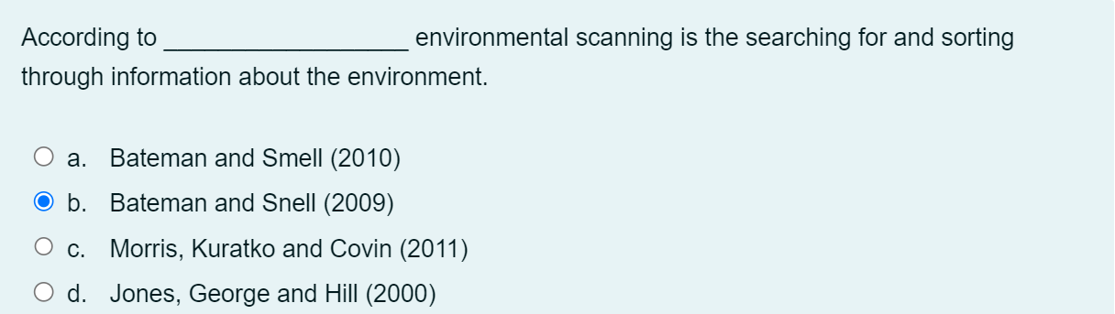

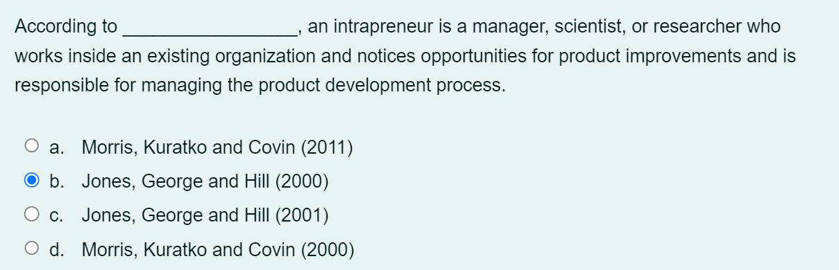

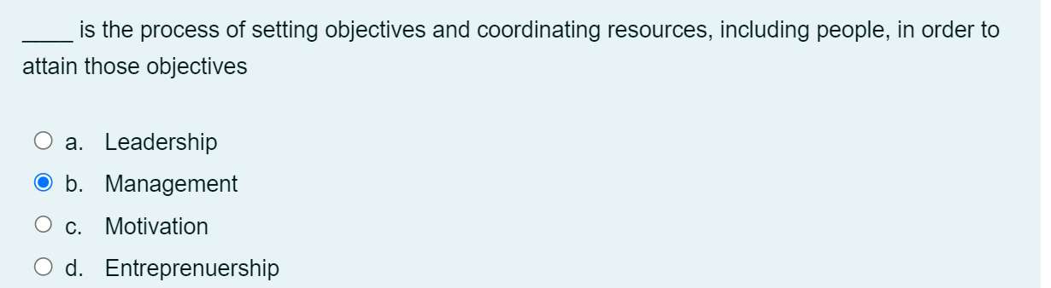

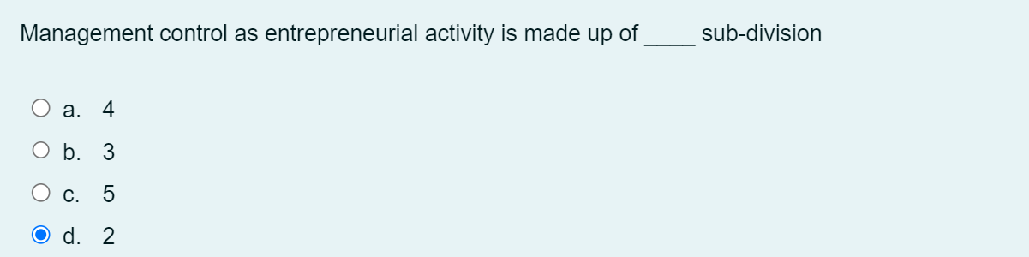

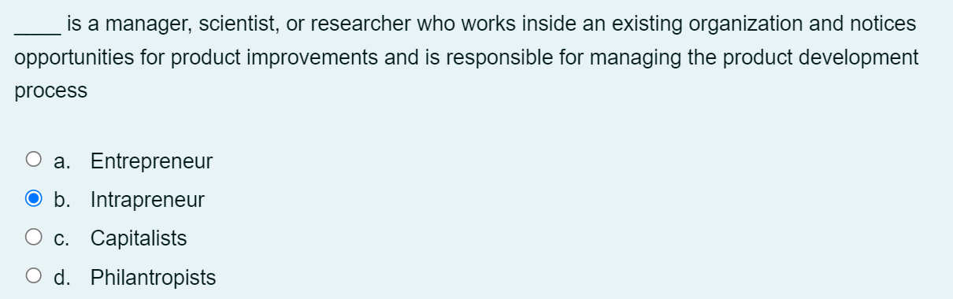

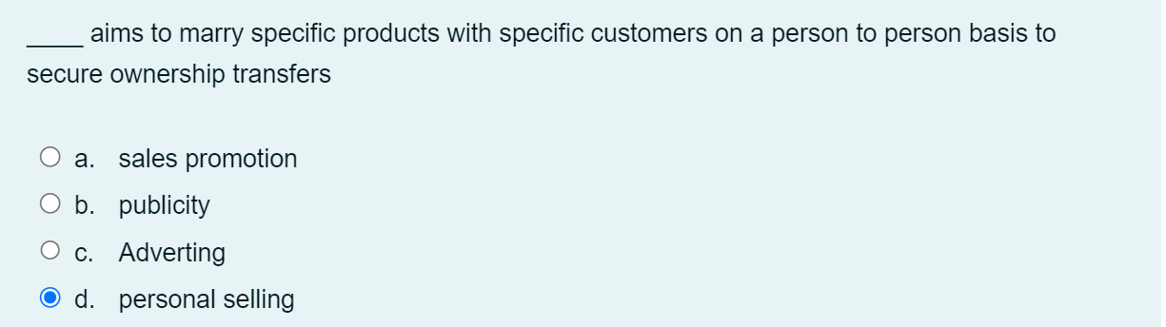

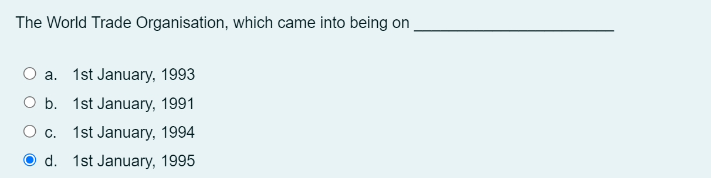

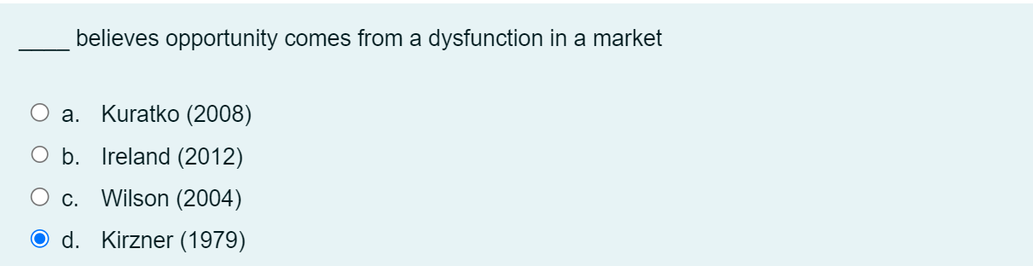

Usually many businesses fail because of the inability of the entrepreneur to gain the support and encouragement of their .........................

a.customers

b.bank

c.organization

1. **families and friends.**

The _______________________________________ of a business is possible when an entrepreneur comes up with an idea for a new business concept or approach.

a.ideas

**b.launching**

c.movement

d.reports

To succeed in the undertaking, the .......................... must possess the relevant and appropriate experience required to excel in his/her chosen niche.

a.manager

**b.entrepreneur**

c.management

d.workers

Which of the following is not true of entrepreneurs?

**a.Intangible goals**

b.High goals

c.Realistic goals

d.Goal commitment

The Market questions focus on the following except

a.Consumer

b.Users of a product

c.Buying habit

**d.Competitors**

____ coined the term intrapreneur to represent an innovative individual (employee) in an existing business organization who perceives new market opportunities, secures resources and initiates the realization of the opportunity

a.Drucker (1986)

b.Wilson (2004)

**c.Pinchot (1985)**

d.Ireland (2012)

______ organizes, manages, assumes the risks and takes the decisions about the enterprise.

**a.Entrepreneur**

b.Capitalists

c.Philantropists

d.Soccialist

Finance identifies the capital that will be required to ............. the business and how it will be used.

a.fund

b.end

c.start

**d.build**

The central role of management in organizations is ?

Question 9Answer

a.Benefit achievement

b.Working together

c.Unity of purpose

**d.Goal attainment**

Business Experience is a fundamental ingredient for the success of any business .........................

**a.venture**

b.growth

c.goals

d.opportunities

]

1. The usefulness of _____________________________________ study can only be appreciated if the techniques of data collection and analysis are objective, valid and reliable.

a.model

b.theory

c.research

**d.feasibility**

2. European Bank for Reconstruction and Development (EBRD) was inaugurated in ____

**a.1991**

b.1994

c.1992

d.1993

3. Which of the following serve to evaluate the viability of a business idea?

a.Business plan

**b.Feasibility study**

c.Risk profile

d.Financial capability

4.The central role of management in organizations is ?

a.Unity of purpose

b.Working together

c.Benefit achievement

**d.Goal attainment**

5. The key objective of a business plan is

**a.sustainability determination**

b.Promotion

c.Profitabiity determination

d.Actionability

6. Operations managers are example of ____ managers

a.Plant

**b.Middle**

c.Top

d.Lower-level

7. The pains and agony of failure of any business may be avoided by subjecting the business idea to ................... analysis.

**a.systematic**

b.feasibility

c.theory

d.data

8. Another name for task environment is ___

Question 8Answer

a.Technological environment

**b.Macro environment**

c.Global environment

d.Operational environment

9. Which of the following is not considered in evaluating business opprtunities?

a.Form of business decision

b.Decision on how to proceed

**c.Decision on incentives**

d.Desire to plunge in

10. Management is applicable in which of the following organizations?

Question 10Answer

a.Church

b.Military

**c.All of the above**

d.Club

1. The usefulness of _____________________________________ study can only be appreciated if the techniques of data collection and analysis are objective, valid and reliable.

a.model

b.theory

c.research

**d.feasibility**

2. European Bank for Reconstruction and Development (EBRD) was inaugurated in ____

**a.1991**

b.1994

c.1992

d.1993

3. Which of the following serve to evaluate the viability of a business idea?

a.Business plan

**b.Feasibility study**

c.Risk profile

d.Financial capability

4.The central role of management in organizations is ?

a.Unity of purpose

b.Working together

c.Benefit achievement

**d.Goal attainment**

5. The key objective of a business plan is

**a.sustainability determination**

b.Promotion

c.Profitabiity determination

d.Actionability

6. Operations managers are example of ____ managers

a.Plant

**b.Middle**

c.Top

d.Lower-level

7. The pains and agony of failure of any business may be avoided by subjecting the business idea to ................... analysis.

**a.systematic**

b.feasibility

c.theory

d.data

8. Another name for task environment is ___

a.Technological environment

**b.Macro environment**

c.Global environment

d.Operational environment

9. Which of the following is not considered in evaluating business opprtunities?

a.Form of business decision

b.Decision on how to proceed

**c.Decision on incentives**

d.Desire to plunge in

10. Management is applicable in which of the following organizations?

Question 10Answer

a.Church

b.Military

**c.All of the above**

d.Club