**TUTOR AYO**

**ECO121**

**TMA SOLUTION FOR EXAM STUDY**

**DO NOT REPRINT FOR SALE**

**THIS IS FREE AND SOLELY FOR EXAM STUDY**

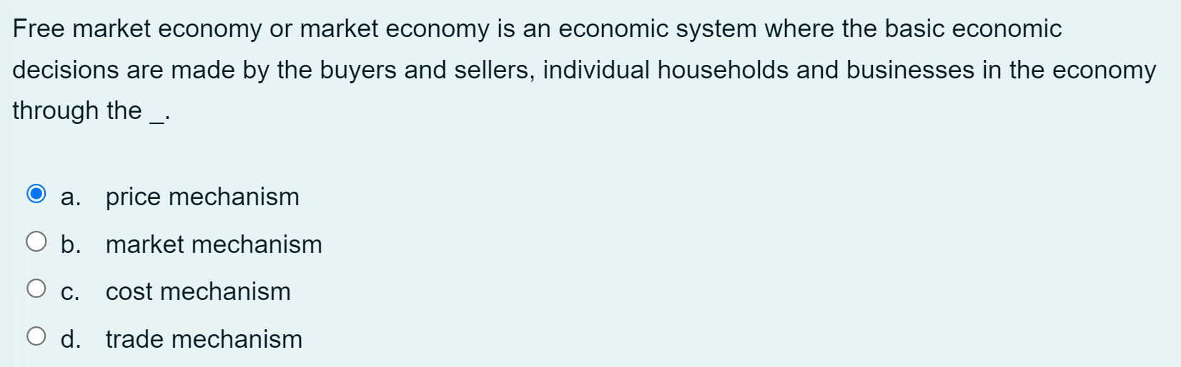

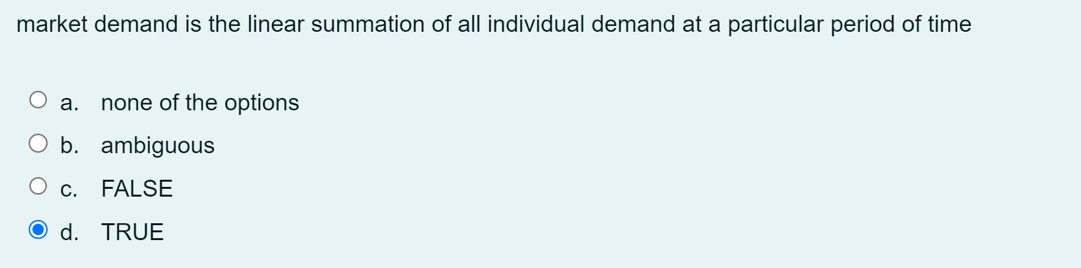

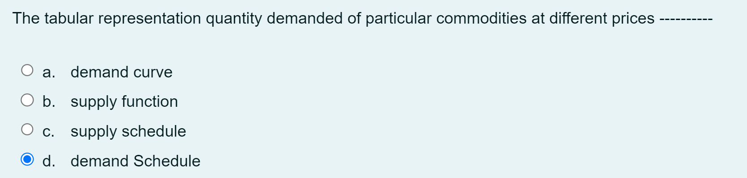

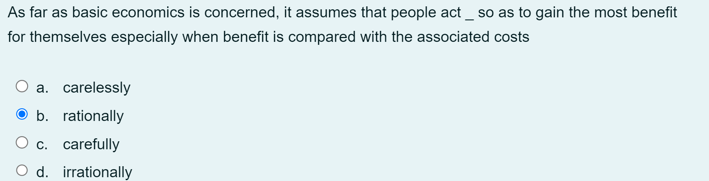

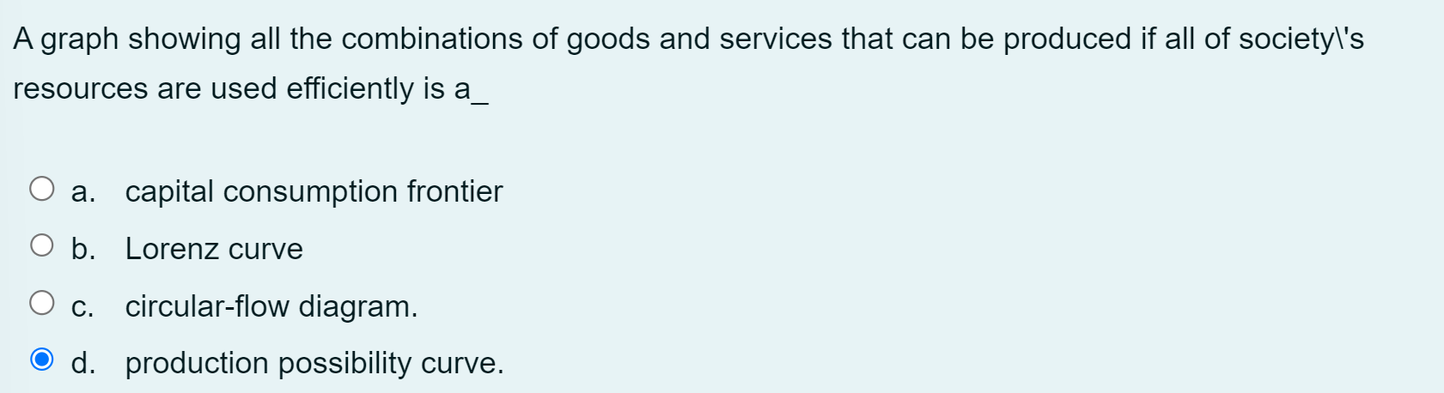



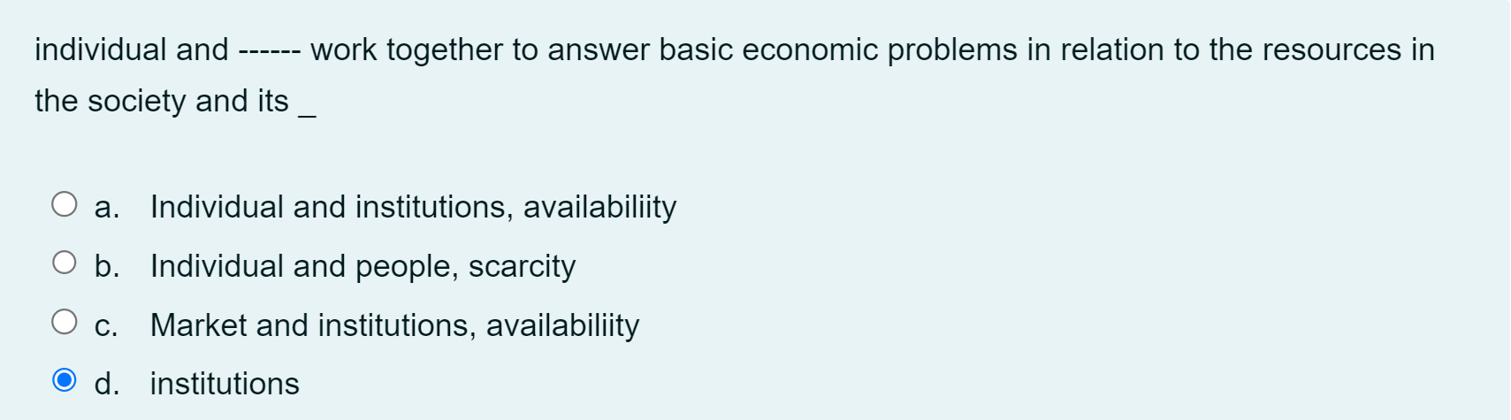

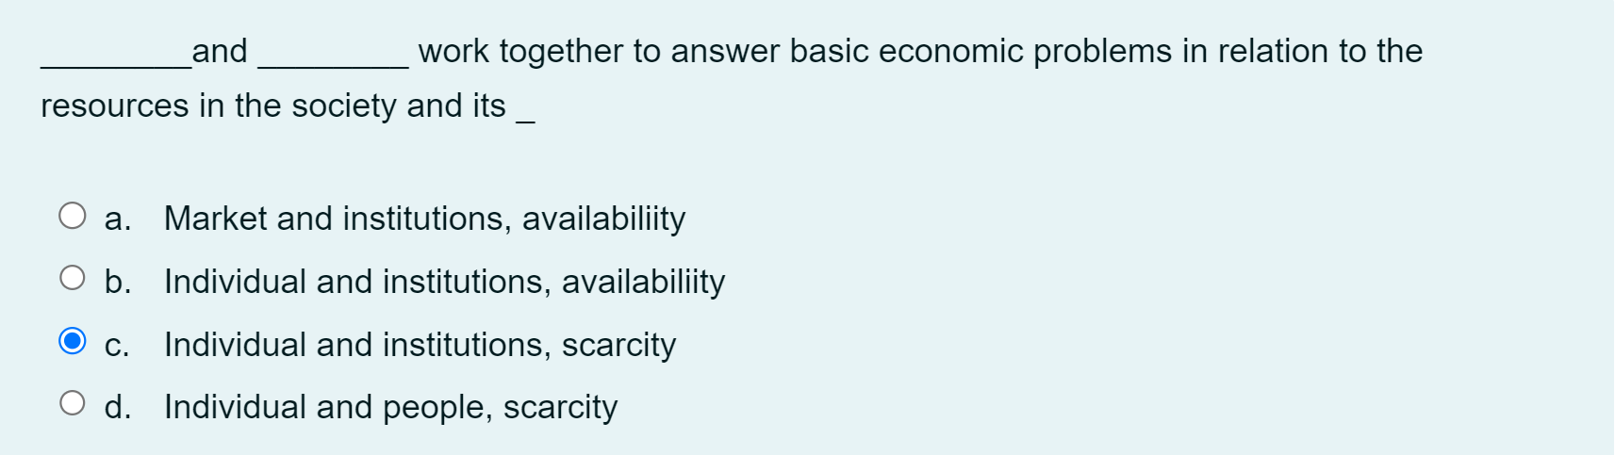

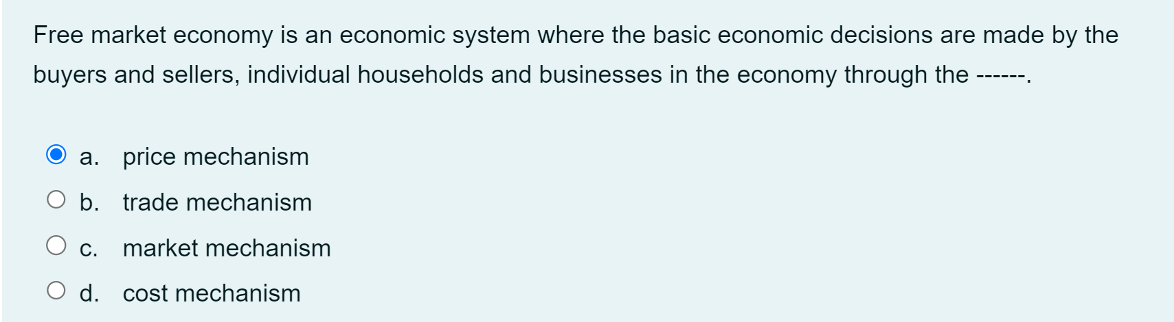

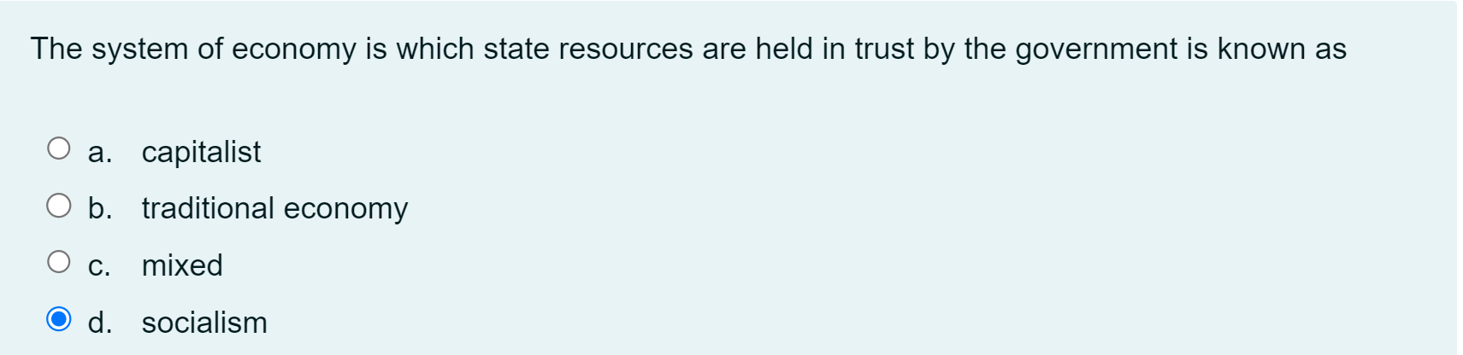

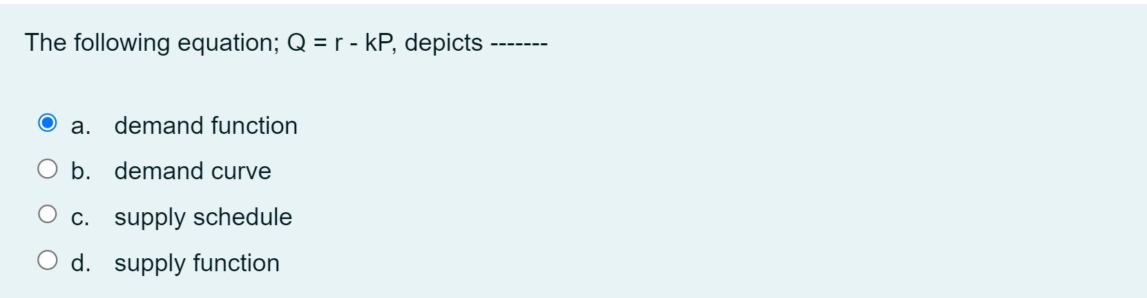

1. one of the following is responsible for change in demand

a.prize

b.price

**c.income of consumer**

d.cost

2. In an imperfect competitive market, ------- stands out as a kind.

a.perfect competitive market

b.oligopoly

**c.monopoly**

d.duopoly

3. The main problems of any economy are, what to produce, how to produce, for whom to produce, and the distribution of products.

a.FALSE

b.Indifference

c.Ambiguous

**d.TRUE**

4. Human wants are ------ and ever dynamic due to ever changing demands and needs for resources which are limited.

a.satisfactory

**b.unlimited**

c.limited

d.exhaustive

5. A perfectly inelastic demand has a coefficient of------

**a.infinity**

b.less than 1

c.greater than 1

d.equal 1

6. The key economic problem is that human wants are unlimited, while resources are ----------

a.surplus

**b.limited**

c.scarce

d.limitless

7. An economic system consists of ------, ----------and their interaction in the process of answering basic_.

**b.individual, institutions; economic issues**

8. The following are types of demand except ----------

a.Complementary

**b.Component**

c.Competitive

d.Composite

9. when two commodities are produced together from the same raw material, the supply is said to be

a.derived supply

b.complimentary supply

**c.complementary supply**

d.composite supply

