**TUTOR AYO**

**CSS121**

**TMA SOLUTION FOR EXAM STUDY**

**DO NOT REPRINT FOR SALE**

**THIS IS FREE AND SOLELY FOR EXAM STUDY**

1. Police organizations in Nigeria have built up array of ………. That help their officers do their work

Ans. Techniques

1. Ivan Pavlov and B. F. skinner are ……..

Ans. Behaviorist

1. The psychological process occurring in the brains of the organism is called…….

Ans. Perception

1. Common (1963) submits that a study of learning is part of the larger study of psychology, which may be defined as the ……. Of human experience and human and animal behavior

Ans. scientific study

1. Gestalt school is a school of psychology of perception originating from…….

Ans. Germany

1. The birth of psychology took place in ……….

Ans. Germany

1. Growth can be horizontally or ………

Ans. Vertically

1. Intelligence is an abstract …………………..

Ans. mental concept

1. Our knowledge and expectation about others are determined by the ……. We formed of them.

Ans. impression

1. The degree to which the consultant can be ………..in police work depends a great deal on who consultant serve

Ans. effective

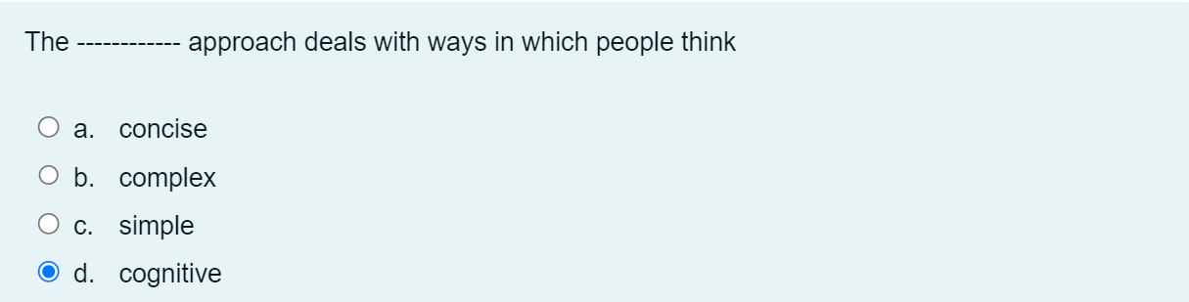

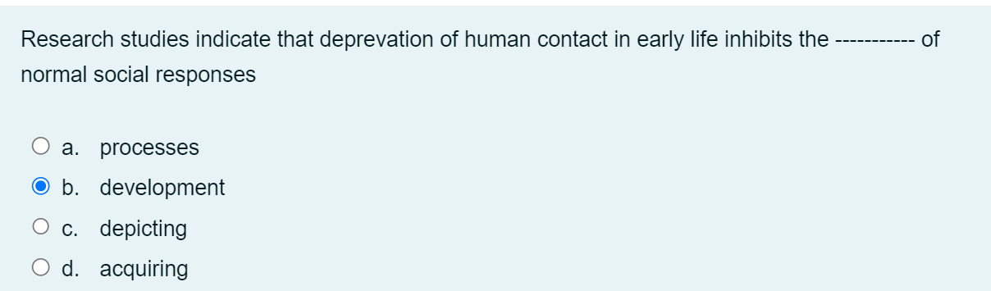

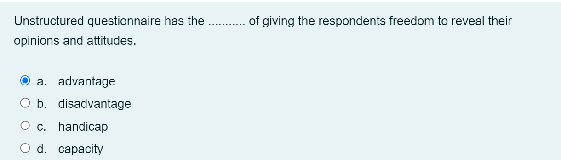

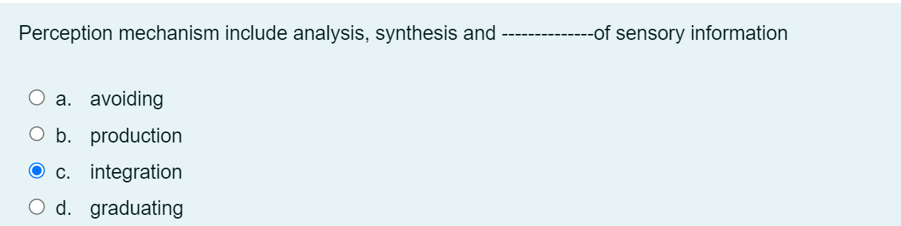

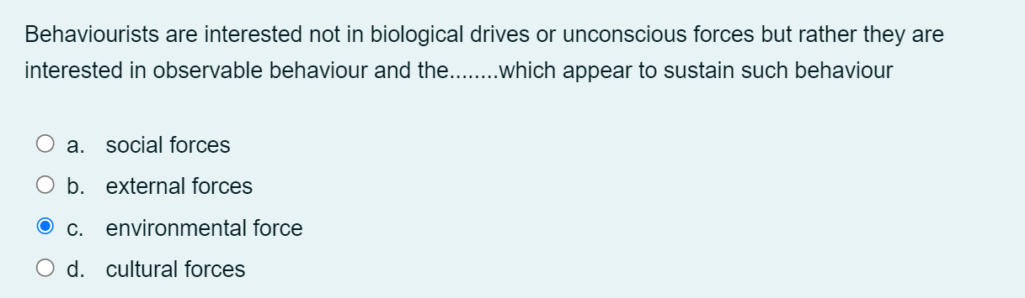

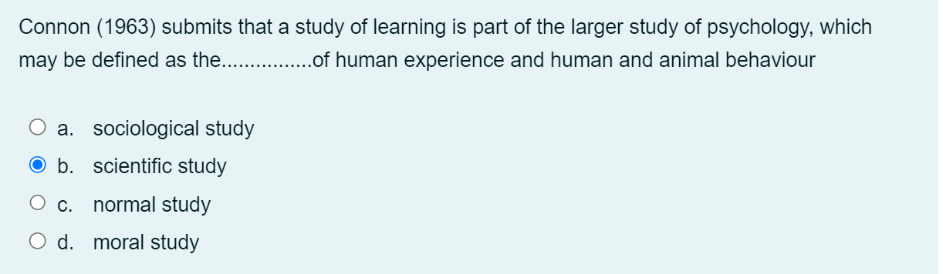

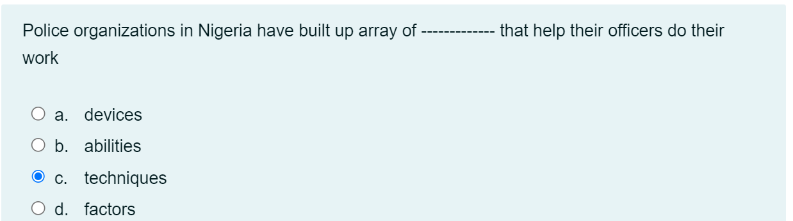

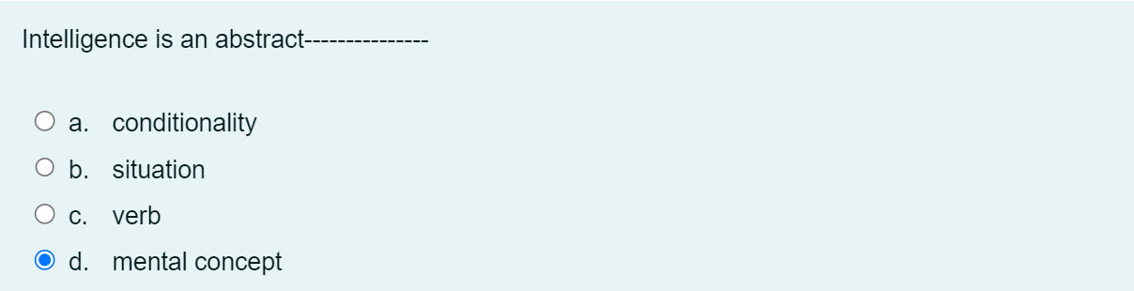

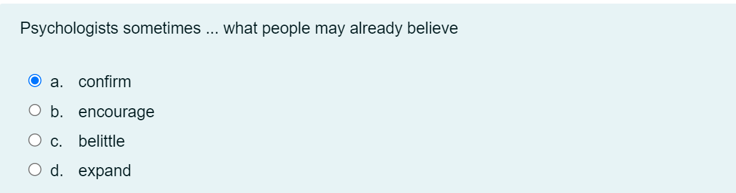



The study of patterns of interrelationship existing in a group of people is called -------

a.knowledge gain

b.progression

**c.sociometry**

d.education

Surveys are------------- conducted in person or through mail which inquire into the way a group of people think

**a.questionnaire**

b.variables

c.Interviews

d.questions

The application of psychology to the area of crime and legal system is called ----------- psychology

a.criminal

**b.forensic**

c.sociology

d.criminology

If anything interferes with the development of an organ at a particular time, it results in ................or malfunctioning.

a.permanent deformity

**b.all of these**

c.permanent deficiency

d.permanent malformation

Human perception is a selective ----------

**b.process**

... provides comprehensive information about the patient being studied

a.Medical approach

**b.Case study**

c.experimental studies

d.Cognitive approach

Iwuji(1981:63) stated categorically that psychology cannot explain human behaviour without................. assumptions about human nature

**a.philosophical**

b.ethnological

c.scientific

d.categorical

Through......., behaviour is understood by reference to the ways in which people think

a.clarification

b.behavioral approach

c.scientific approach

**d.cognitive approach**

The term socialization is broad enough to cover all types of -----------

a.abilities

b.interests

c.skills

**d.learning**

In a short form, psychology is the scientific study of.................

**a.human behaviour**

b.human nuture

c.human story

d.human life

CSS121

1. In the case of impression formation, the main ----------- is that most salient cue will be used most heavily

Question 1Answer

a.situation

b.issue

**c.implication**

d.event

2. Kohler (1925) explained learning as a perceptual process with the major emphasis being on the study of.............. and how people learn to see relationships among various items of experience.

Question 2Answer

a.fussion

**b.relationships**

c.disassociation

d.association

3. Freud argued that ---------------- is a primary instinct in the living species who have survived through the ages during evolution

Question 3Answer

**a.aggression**

b.fighting

c.killing

d.conflict

4. Physical growth can be measured in terms of height and ------------

Question 4Answer

a.broadness

b.length

c.size

**d.weight**

One of the goals of psychology according to Zimbardo (1992) is to............ describe the behaviour of individuals.

Question 5Answer

a.partially

b.unjustly

**c.objectively**

d.subjectively

6. The juvenile delinquent is neither a rejected youngster nor a young ---------

Question 6Answer

a.inmate

b.girl

c.boy

**d.criminal**

7. Psychological ..... allows people to ascertain the conditions under which certain events do or do not occur

Question 7Answer

a.cases

**b.research**

c.schools

d.laboratory

8. Policing involves the use of a wide range of ------------

Question 8Answer

a.activities

**b.skills**

c.things

d.action

9. ...........founded the first laboratory devoted to experimental psychology

Question 9Answer

a.Freud

b.Piaget

**c.Wilhelm Wundt**

d.Bandura

A .......... contains the questions and alternative answers to them.

Question 10Answer

a.opinion polls

b.In depth interview

c.open ended questionnaire

**d.structured questionnaire**