**TUTOR AYO**

**BUS105**

**TMA SOLUTION FOR EXAM STUDY**

**DO NOT REPRINT FOR SALE**

**THIS IS FREE AND SOLELY FOR EXAM STUDY**

Join our general Whatsapp group for regular updates

 **<https://chat.whatsapp.com/InKqirCrhnF9KJozucXWCh>**

 **<https://tutorayo.com/>**

1

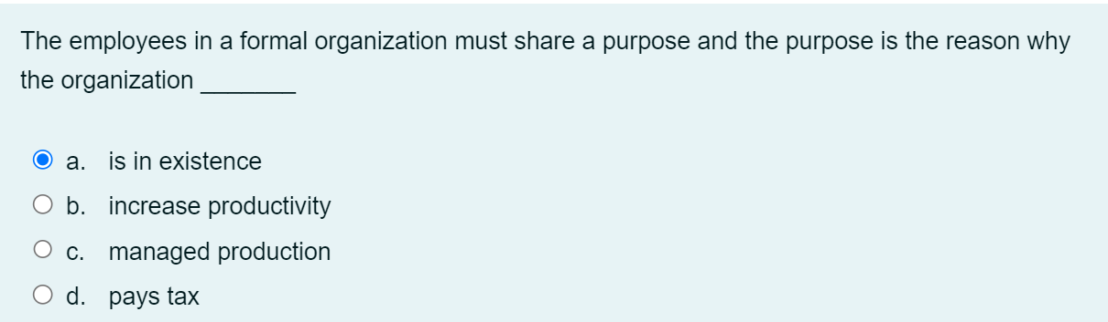

2

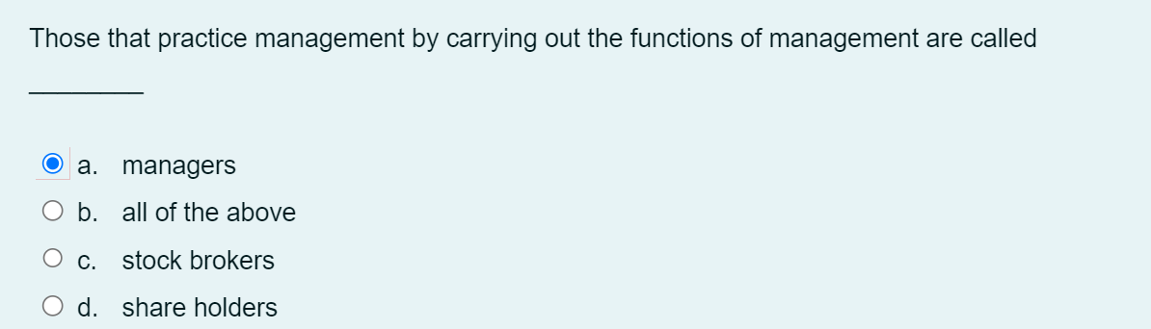

3

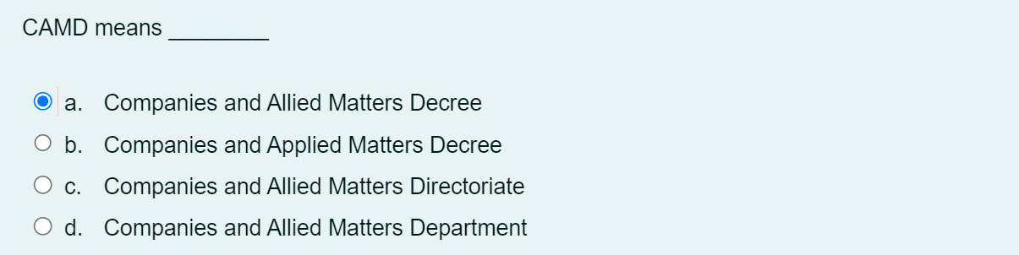

4

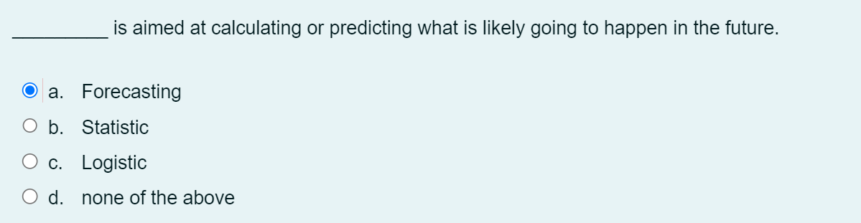

5

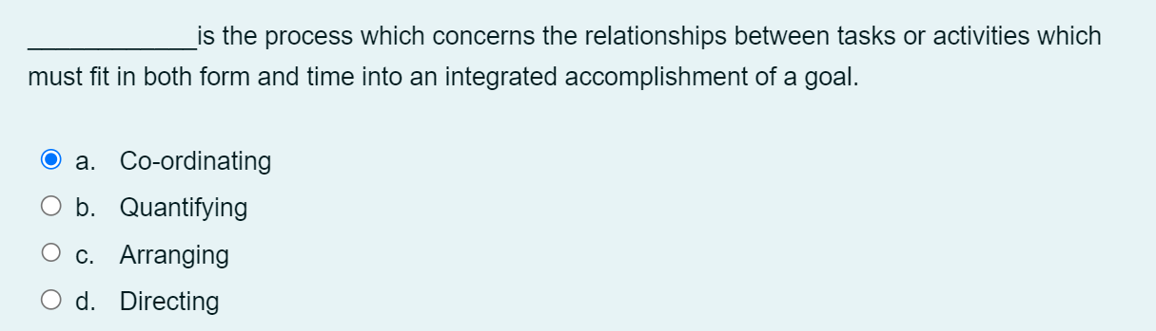

6

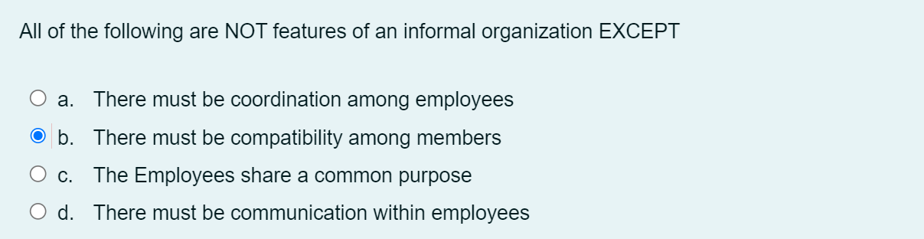

7

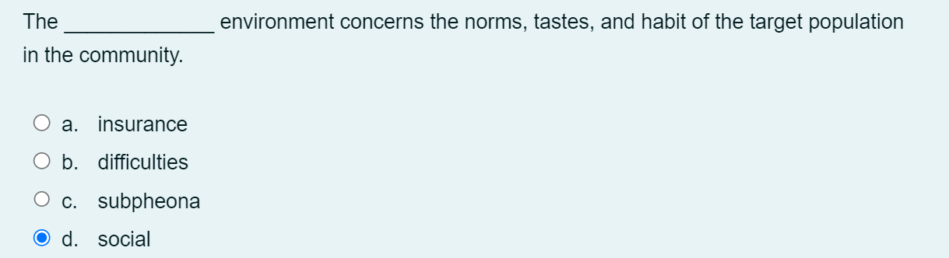

8

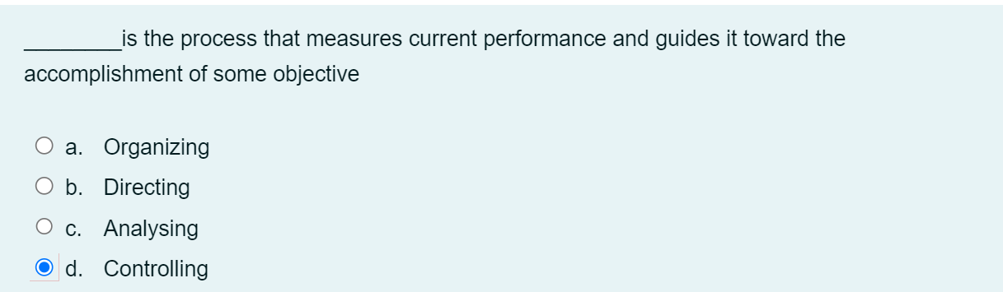

9

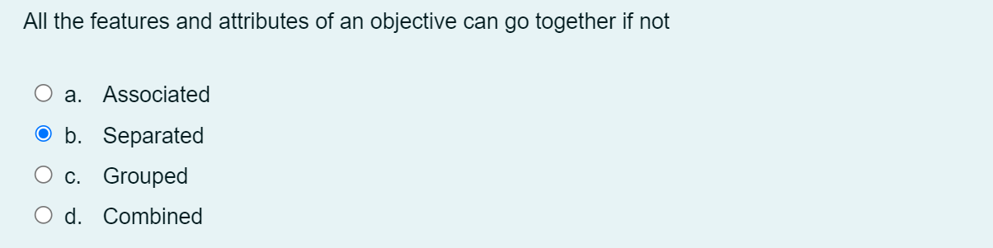

10

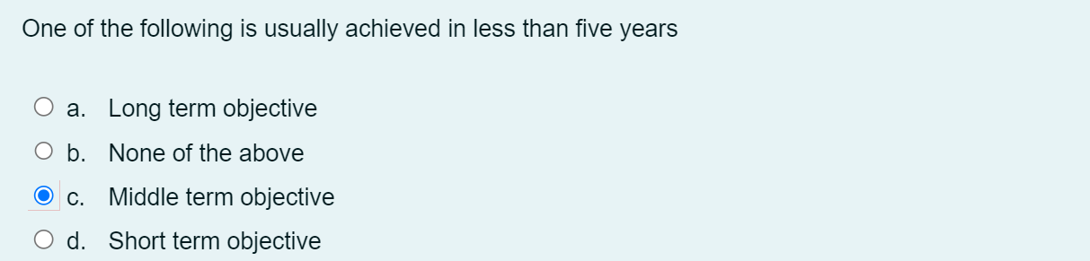

1. The aim of all managers whether a senior manager or a junior one is the same it is to make surplus or what some people called……….

Ans. Profit

1. …………… is the ability to solve problems in ways that will benefit the organization

Ans. design skill

1. For a new employee, …………is designed to make him familiar with his new work environment

Ans. Training

1. The employees in a formal organization must share a purpose and the purpose is the reason why the organization ……..

Ans. is in existence

1. ………….. distribution, expenditure patterns, saving capability of consumers all effect demands

Ans. income

1. The manager must comply with the ……….. requirements for establishing and operating his business

Ans. legal

1. Training in an organization is very essential and is needed for

Ans. new and existing employees

1. ……………. Means the breaking down of the main content of job

Ans. job analysis

1. The manager must comply with the ……………….. requirements for establishing and operating his business

Ans. legal

1. Company ……….. are also part of the data which have to be processed

Ans. records

1. The appropriate Law(s) to register the business depends on

a.the type of business

1. The managerial function of ________ is simply the process of influencing people so that they will contribute to the goals of the organization.

b.Leading

1. _____________ are qualities of a good leader:

a.Emotional stability

**b.All of the above**

c.social skills

d.Empathy

1. ___________________ is consequently more embracing and pervasive.

a.legislation

b.administrative

**c.management**

d.executive

1. Older employees can also benefit from training through ____________ of skills.

a.none of the options

b.Improving

**c.Updating**

d.upscaling

1. There are ________ essential elements of coordination

Question 6Answer

**a.Two**

b.Three

c.Four

d.Zero

1. The noun_________ is used as a collective noun to refer to all those who manage within a particular organization.

a.Clearance

**b.Management**

c.Maintenance

d.Renovation

1. The staff manager does not exercise authority over the _________________ .

a.Manager

b.production manager

c.Staff manager

**d.Line manager**

1. The manager has control over the ____________ environment in the process of managing.

a.international

**b.internal**

c.exterior

d.external

1. Whatever position you find yourself in an organization, you will feel the presence of ______________________

Question 10Answer

a.employers

b.managing

c.manager

**d.management**

1. Which of the following types of training makes use of models

a.Technical training

b.Executive trainning

c.Apprenticeship trainning

**d.Simulated trainning**

3. ______________ does not concerns itself with policy formulation

a.Company

b.policy

**c.Management**

d.road map

4. A ________ is a guide to action and provides the direction that all organizational efforts will follow

**a.policy**

b.Organogram

c.Tower

d.strategical plan

5.The ________is responsible for developing and approving major comprehensive company policies.

**a.Manager**

b.CEO

c.boss

d.management

6. A good leader, in exercise of his qualities ensure good human relations. Which among the techniques is commonly adopted

a.Use of participation

b.Closeness of supervision

c.Consistency and fairness

**d.All of the above**

7. The ____________ has a group of subordinates or the doers or operatives reporting to him

a.instinct

**b.manager**

c.emotion

d.attitude

8. The ____________ manager on his own interest will regard management as employing suitably qualified candidates to fill existing vacancies and motivating them to work as a team toward the attainment of organizational objectives.

a.strategical plan

b.Tower

**c.personnel**

d.Organogram

9. Growth objective is an example of

**a.Business objective**

b.Legal objective

c.Broad objective

d.Management Objective

10. The following are signs showing that control are inadequate except

**a.Promptness**

b.Late correction

c.A and B

d.Unnecessary excuse